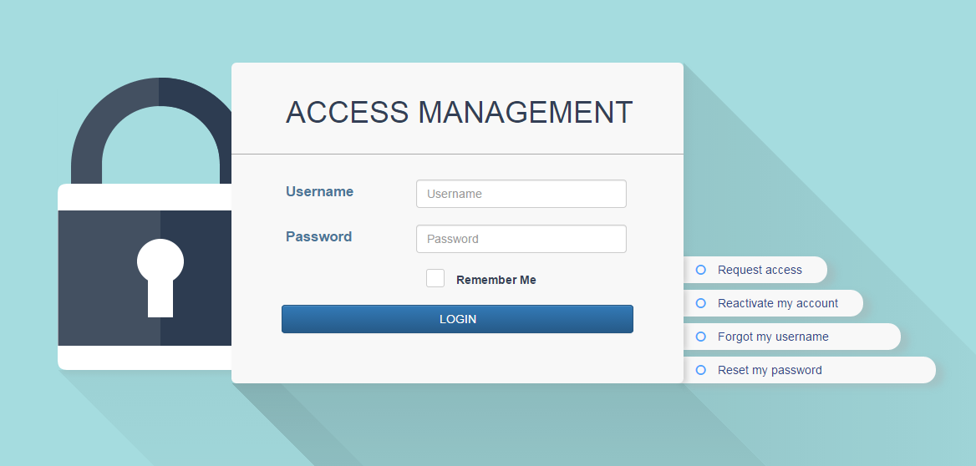
Access Management User Guide (Users)
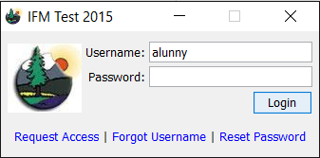
The Access Management system was developed to increase security to the IFM and FMT applications. The new system was also developed to ease the user and administrator experience.
Requesting a new account
- New Users can request access from:
  - The IFM login pop-up (Request Access link) OR
  - Directly from the Access Management web page
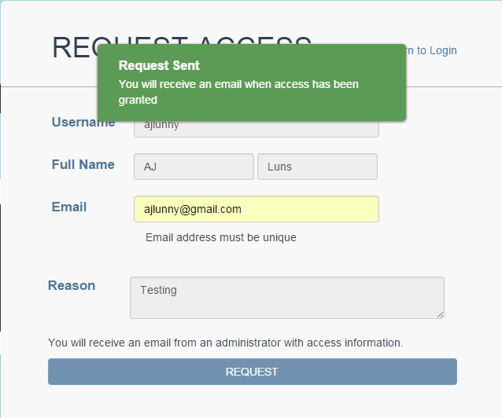
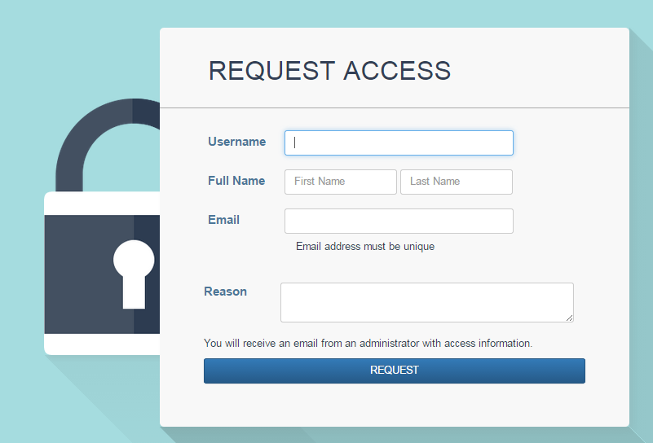
- All fields on the ‘Request Access’ form are required before a request can be sent.
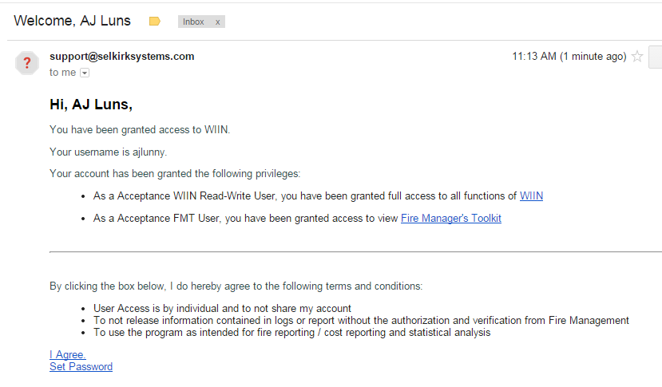
- Once a request is sent, users will have to wait for an Administrator to provide access to the system. The user will receive an email when access is granted, indicating the specific roles they were given and links to those applications.
- Users will be required to agree to the Terms and Conditions indicated in the email. Upon agreement, will need to set a Password by clicking the ‘I Agree, Set Password’ link
- Users will be brought to the ‘Set Password’ page in Access Management. All passwords must follow the requirements laid out on the page.
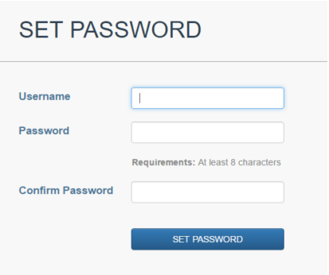
- After setting a password, users will be able to log into the applications they have been given access to
Existing Accounts
- Users who have existing accounts in the system from previous years can simply request to have their accounts Reactivated. This is also where users can come to request reactivation in the case of account lockout (password expired, account expired, password lockout). Users can request account Reactivation from:
  - The IFM login pop-up (Request Access link) OR
  - Directly from the Access Management main page
- Users receive an email when their account has been Reactivated by an Admin
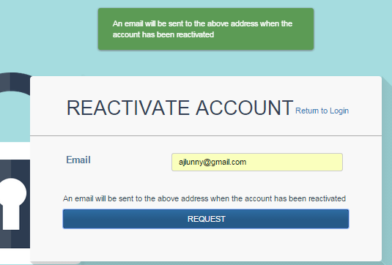
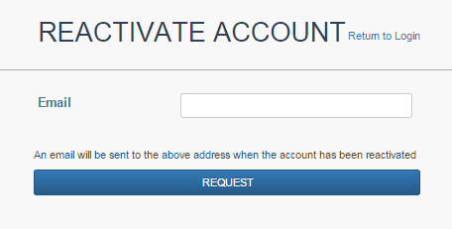

Administrator provides Access
- In some cases user’s accounts are created by Access Management Administrators. The user will receive an email when their account has been activated, with the requirement to accept Terms and Conditions and change Password.
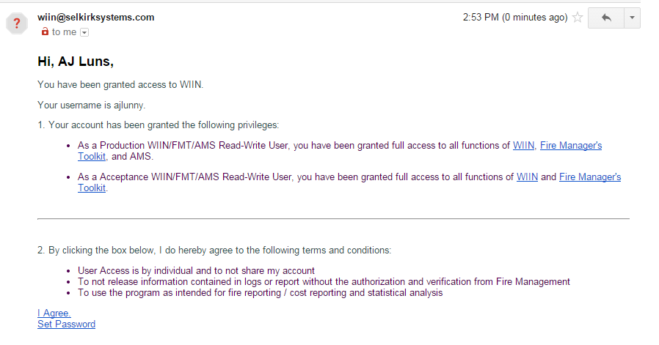
- Users will need to follow the links to change their password (See above for details)

Forgot Username
- To retrieve a Forgotten Username, users can:
  - click on the ‘Forgot Username’ link on the IFM Login screen OR
  - click on the ‘Forgot my Password’ link directly from the Access Management page
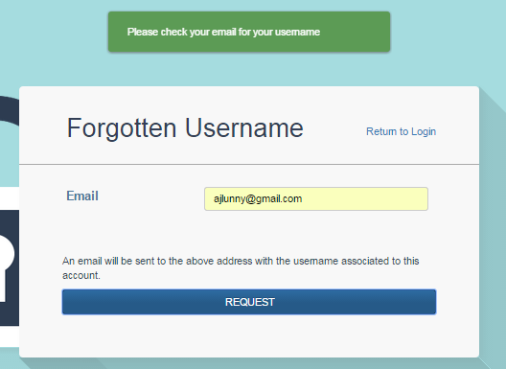
- Enter the email address associated with that username and an email will be sent with Username
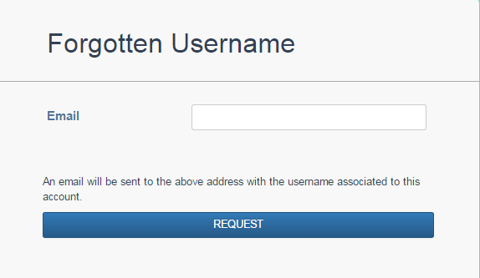

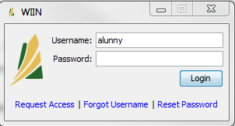
Reset Password
- To retrieve a Forgotten Password, users can:
  - click on the ‘Reset Password’ link on the IFM login OR
  - go directly to the User Management Reset password page
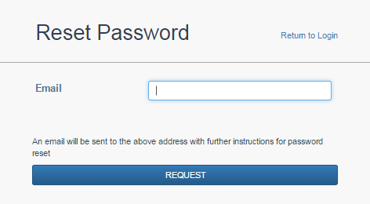
- The user will be prompted to enter your email associated with the account
- A link to the ‘Set Password’ page will be automatically emailed (same as noted above)
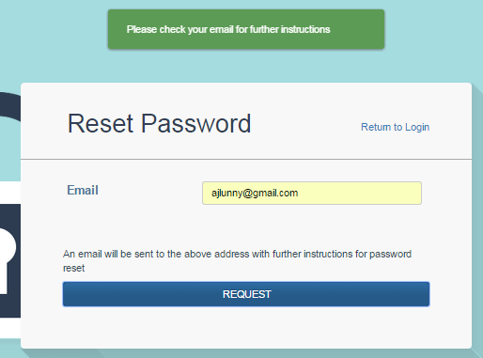

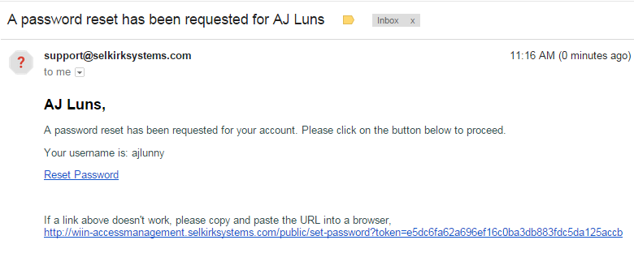
- If an Admin resets your password, you will receive an email similar to the one below with access to reset your own password
- In the final step, users must enter their username and new password twice. Their new Password must conform to the listed Requirements.

Password Expiry/ Locked Accounts
- Accounts can be locked out in the following situations:
  - Failed Password max: Attempting to login unsuccessfully 3+ times will lock a user account out
    - In this situation, the user must reset their password. This can be done so by clicking the ‘Reset Password’ link from the IFM Login page or on the Access Management home page
  - Password has expired: For security reasons, after a pre-determined amount of time; passwords will expire and need to be reactivated.
    - In this situation, users are again required to reset their password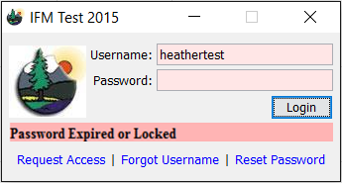
  - Account Expiry: For security reasons, after a pre-determined amount of time (e.g. the end of a fire season) accounts will be expired and need to be reactivated.
    - In this situation, users must request to have their account reactivated (request access) and an Admin will need to provide access once again
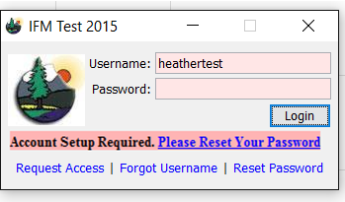

Logging in to Access Management
- Users can log in directly to the Access Management webpage to view their account information. The information is not editable, but the user does have the ability to change their password. Other account edits (eg: email address, username, Full Name, Roles & access) will have to be requested through an IFM Administrator.

